


LAB WEEK 10
  - SEP 2026 SEMESTER

‘AFFAN NAJIY BIN RUSDI
22010453
BACHELOR OF COMPUTER SCIENCE
MODELING AND SIMULATION
TEB2103

Contents
Exercises 3
Exercise 1 3
Exercise 2 5
Exercise 3 6
Exercise 4 7

Exercises

Exercise 1
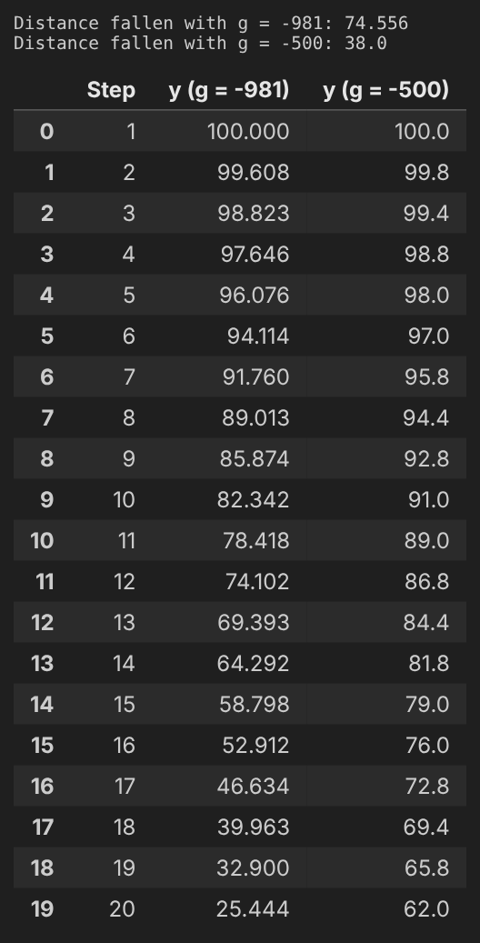

Explanation
Firstly, the gravity was changed from (0, -981) to (0, -500), while the mass stayed at 10, and both boxes were stepped 20 times. The box with -981 gravity dropped from y = 100 to y = 25.444, while the box with -500 gravity only dropped to y = 62.0. Hence, the box fell 38.0 units instead of 74.556, which is about half, as the gravity was also nearly halved. This is similar to dropping a ball on the Moon, where it falls much slower than on Earth.

Code
# Same setup as Example 4, but saves every step into a table
def run_box(gravity, mass, steps):
space = pymunk.Space()
space.gravity = (0, gravity)

body = pymunk.Body()
body.position = (50, 100)

box = pymunk.Poly.create_box(body)
box.mass = mass

space.add(body, box)

rows = []
for i in range(steps):
space.step(0.02)
rows.append({"Step": i + 1,
"Time (s)": round((i + 1) * 0.02, 2),
"y": round(body.position.y, 3),
"Velocity y": round(body.velocity.y, 3)})
return pd.DataFrame(rows)

g981 = run_box(-981, 10, 20)
g500 = run_box(-500, 10, 20)

print("Distance fallen with g = -981:", round(100 - g981["y"][19], 3))
print("Distance fallen with g = -500:", round(100 - g500["y"][19], 3))

ex1 = pd.DataFrame({"Step": g981["Step"],
"y (g = -981)": g981["y"],
"y (g = -500)": g500["y"]})
ex1

Exercise 2
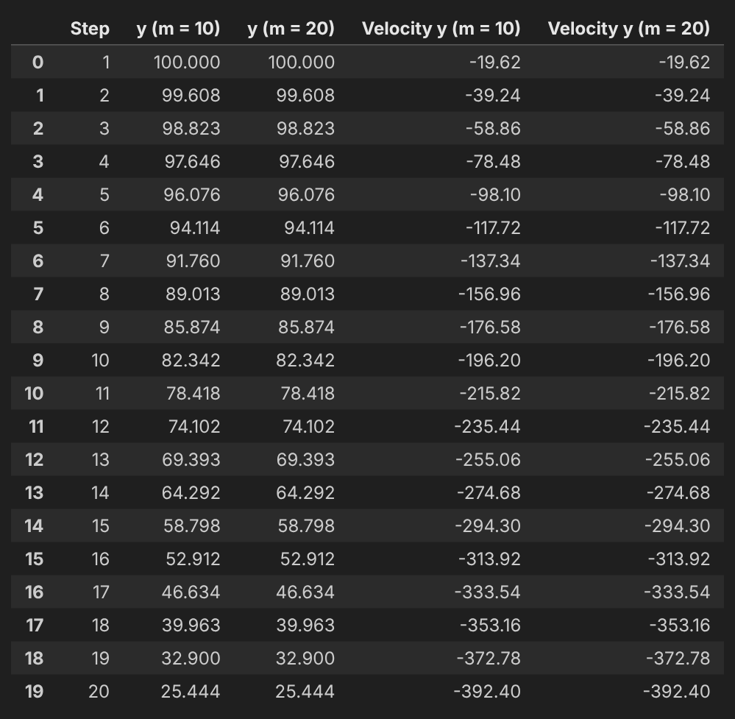

Explanation
Secondly, the mass of the box was changed from 10 to 20 using `box.mass = 20`, while the gravity stayed at (0, -981). After 20 steps, both boxes ended at y = 25.444 with a velocity of -392.4, so doubling the mass changed nothing. This is because a heavier box gets a bigger pull but is also harder to move, whereby the two cancel out. This is similar to dropping a heavy stone and a light stone together, where both land at the same time.

Code
m10 = run_box(-981, 10, 20)
m20 = run_box(-981, 20, 20)

ex2 = pd.DataFrame({"Step": m10["Step"],
"y (m = 10)": m10["y"],
"y (m = 20)": m20["y"],
"Velocity y (m = 10)": m10["Velocity y"],
"Velocity y (m = 20)": m20["Velocity y"]})
ex2

Exercise 3
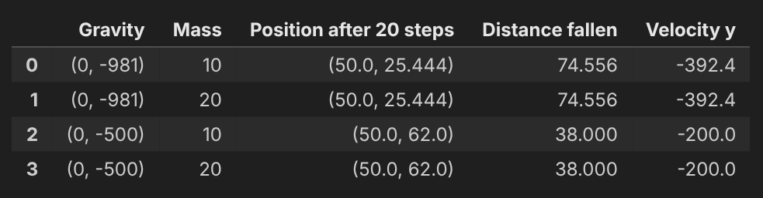

Explanation
Thirdly, all four cases were run for 20 steps, which is 0.4 seconds of simulated time. The two boxes with -981 gravity ended at (50.0, 25.444) and the two with -500 gravity at (50.0, 62.0), whether the mass was 10 or 20. The x position stayed at 50, as there is no sideways gravity. Therefore, only gravity decides how far the box falls, similar to the hammer and feather that were dropped together on the Moon in Apollo 15 and landed at the same time.

Code
rows = []
for g in [-981, -500]:
for m in [10, 20]:
df = run_box(g, m, 20)
rows.append({"Gravity": (0, g),
"Mass": m,
"Position after 20 steps": (50.0, df["y"][19]),
"Distance fallen": round(100 - df["y"][19], 3),
"Velocity y": df["Velocity y"][19]})
ex3 = pd.DataFrame(rows)
ex3

Exercise 4
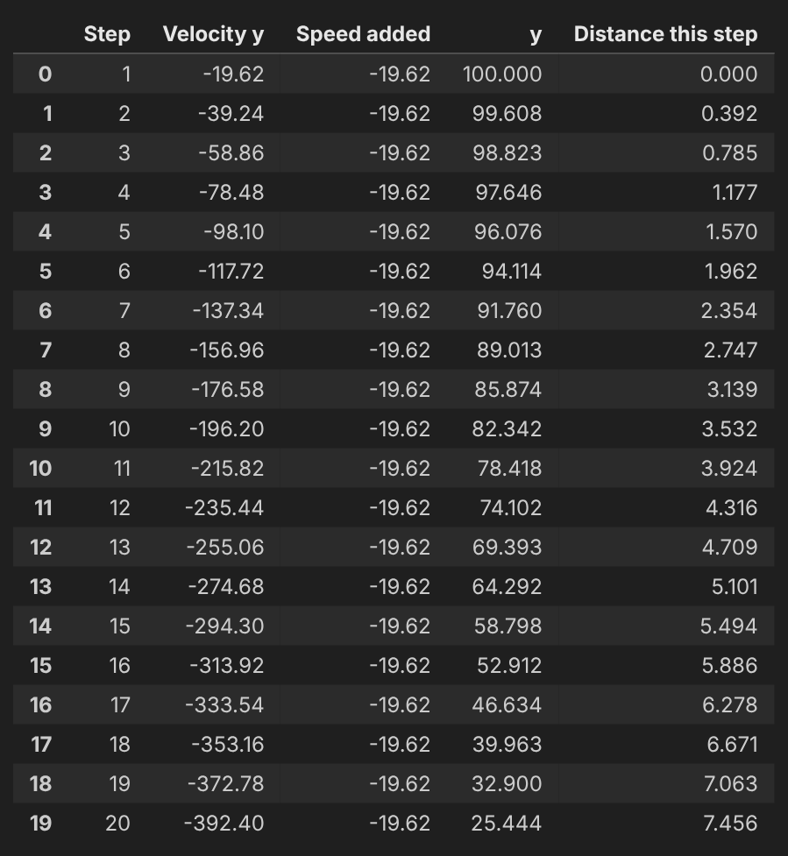

Explanation
Lastly, the box moves downward because the gravity is (0, -981), and the y-axis in Pymunk points up, so a negative value pulls it down. Every `space.step(0.02)` adds 981 x 0.02 = 19.62 to the downward speed, which reaches -392.4 after 20 steps. The box does not move in step 1, as Pymunk moves it before adding speed, but then falls 0.392 units in step 2 and 7.456 in step 20. This is similar to a ball rolling down a slope, getting faster the longer it rolls.

Code
ex4 = run_box(-981, 10, 20)

rows = []
last_y = 100
last_v = 0
for i in range(20):
y = ex4["y"][i]
v = ex4["Velocity y"][i]
rows.append({"Step": i + 1,
"Velocity y": v,
"Speed added": round(v - last_v, 3),
"y": y,
"Distance this step": round(last_y - y, 3)})
last_y = y
last_v = v
pd.DataFrame(rows)



